

|  |
| --- |
| Experiment No. 2 |
| Basic gates using universal gates. |
| Name: Vishwatej Sarang |
| Roll Number: 51 |
| Date of Performance: |
| Date of Submission: |

**Objective -**

1. To study the realization of basic gates using universal gates.
2. Understanding how to construct any combinational logic function using NAND or NOR gates only.

**Theory -**

AND, OR, NOT are called basic gates as their logical operation cannot be simplified further.

NAND and NOR are called universal gates as using only NAND or only NOR, any logic function can be implemented.

**Components required -**

1. IC’s 7400(NAND) 7402(NOR)

2. Bread Board.

3. Connecting wires.

**Circuit Diagram -**

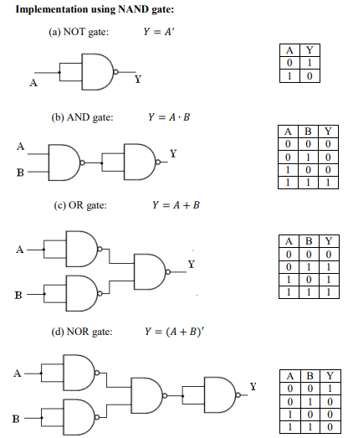

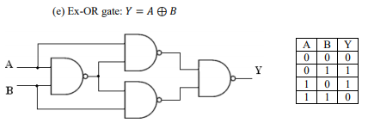

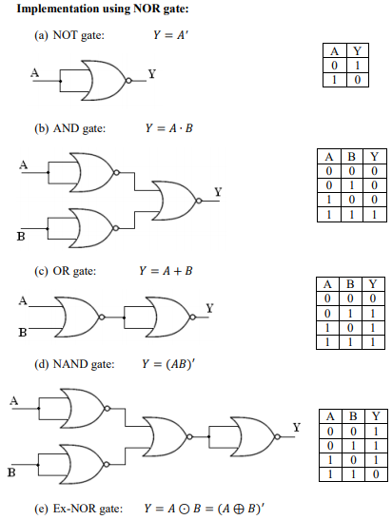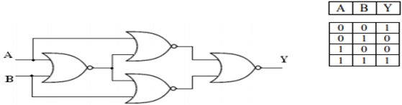

**Procedure:**

a) Connections are made as per the circuit diagrams.

b) By applying the inputs, the outputs are observed and the operations are verified with the help of truth table.

**Output:**

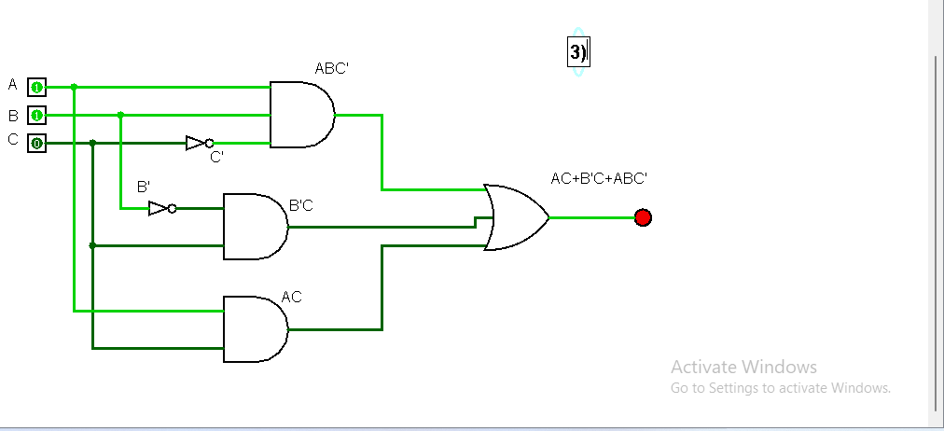

**Conclusion** –

In this lab, I explored the function of the basic logic gates. I learned how to implement them on a breadboard with integrated circuits. I tested the output voltage of the breadboard circuits using the multi-meter, and ensured the results corresponded with the truth table of the logic gate tested. Students learn how to follow the lab manual, how to use the breadboard, how to use the equipment in the lab, and how to properly design and test a circuit